**ARTIFACTORY SETUP**

**NOTE: jfrog-artifactory-oss-4.0.2 version and above need java version 1.8.0_45 and above.**

Step 1: Download and install the jdk 1.8.0_45 or above and set the JAVA_HOME in the ~/.bashrc file and

source the file by

**$ source ~/.bashrc**

Step 2: Download Artifatory Zip file form <http://www.jfrog.com/open-source>

Step 3: Unzip the zip file at desirable location preferably /opt/

Step 4: Set the ARTIFACTORY_HOME in the ~/.bashrc file as

**ARTIFACTORY_HOME="/opt/artifactory-os0s-4.0.2"**

Step 5: Change directory to /opt/artifactory-oss-4.0.2/bin and give the executable permission to

* artifactoryctl
* artifactory.sh
* installService.sh

**$ chmod 777 artifactoryctl artifactory.sh installService.sh**

Step 6: Stop all processes that is running on port 8081.

Step 7: Try running the artifactoryctl and see the status.

Step 8: Run the script file /opt/artifactory-oss-4.0.2/bin/installService.sh present in the bin folder, it will

set few class paths and register the process in the startup services.

**$ sh installService.sh**

Step 9: Open the file /etc/opt/jfrog/artifactory/default and set the JAVA_HOME and others if required.

Step 10: Run the command **sudo service artifactory check** and check if everything seems alright.

Step 11: Now Start artifactory service by going to /opt/artifactory-oss-4.0.2/bin and run

**./artifactoryctl restart**

Step 12: Now hit the URL localhost:8081/artifactory

**NOTE: For more Information visit** [**http://devopsnet.com/2012/07/24/installing-artifactory-on-ubuntu/**](http://devopsnet.com/2012/07/24/installing-artifactory-on-ubuntu/)

**CREATING REPO, USERS AND SETTING PERMISSIONS**

Step 1: Creating Repo

* Go to **Admin** -> **Repositories** -> **Local** -> **New**
* Select **Generic** as package type

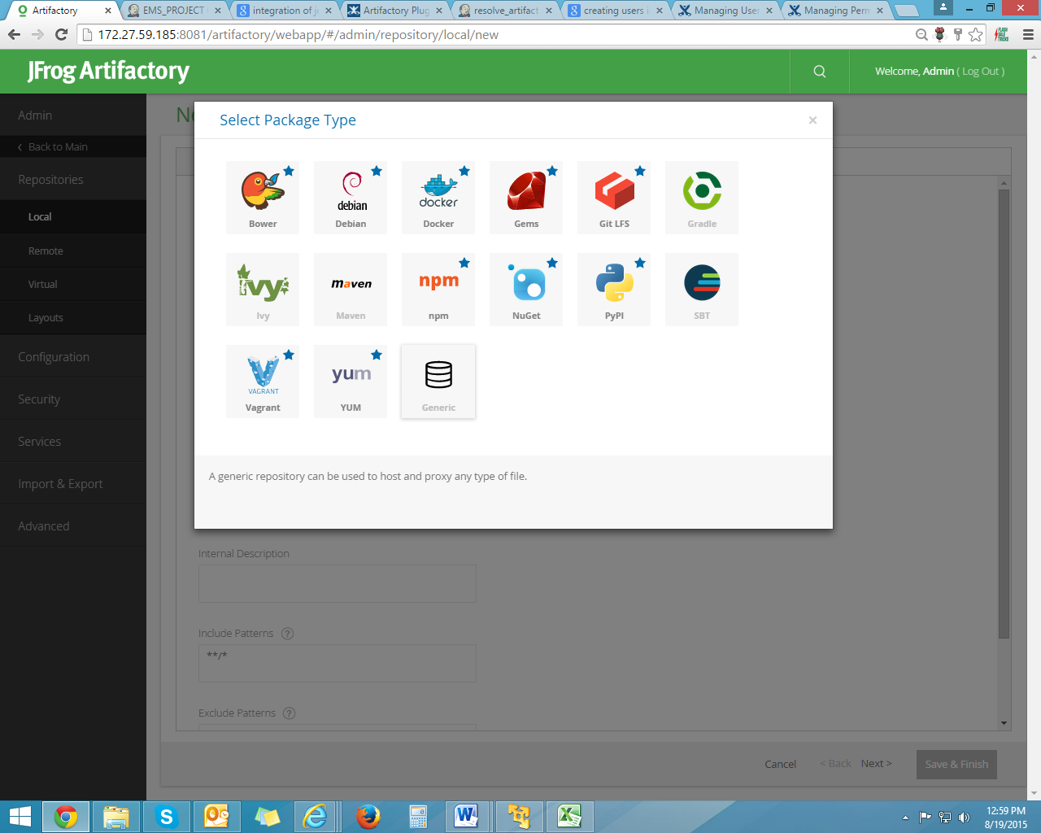

* Write Repository name in **repository key**

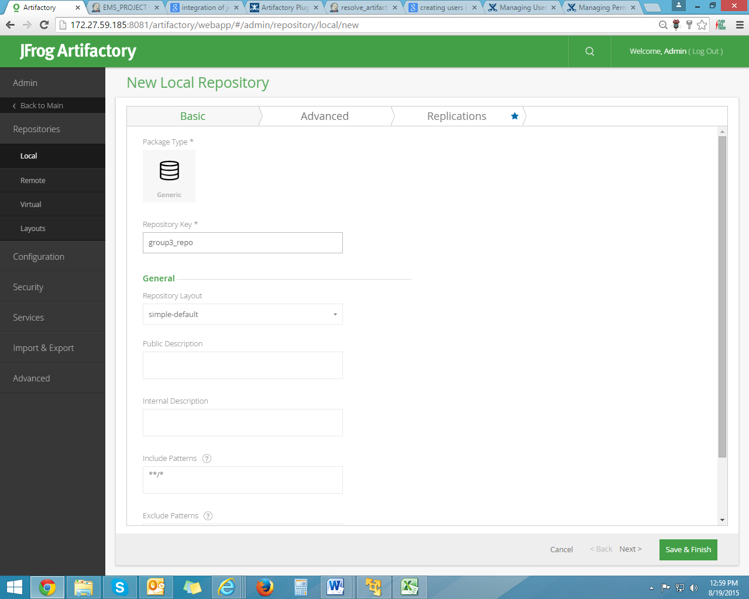

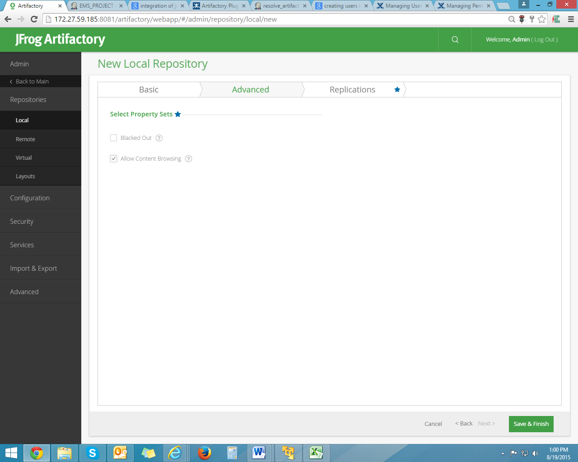

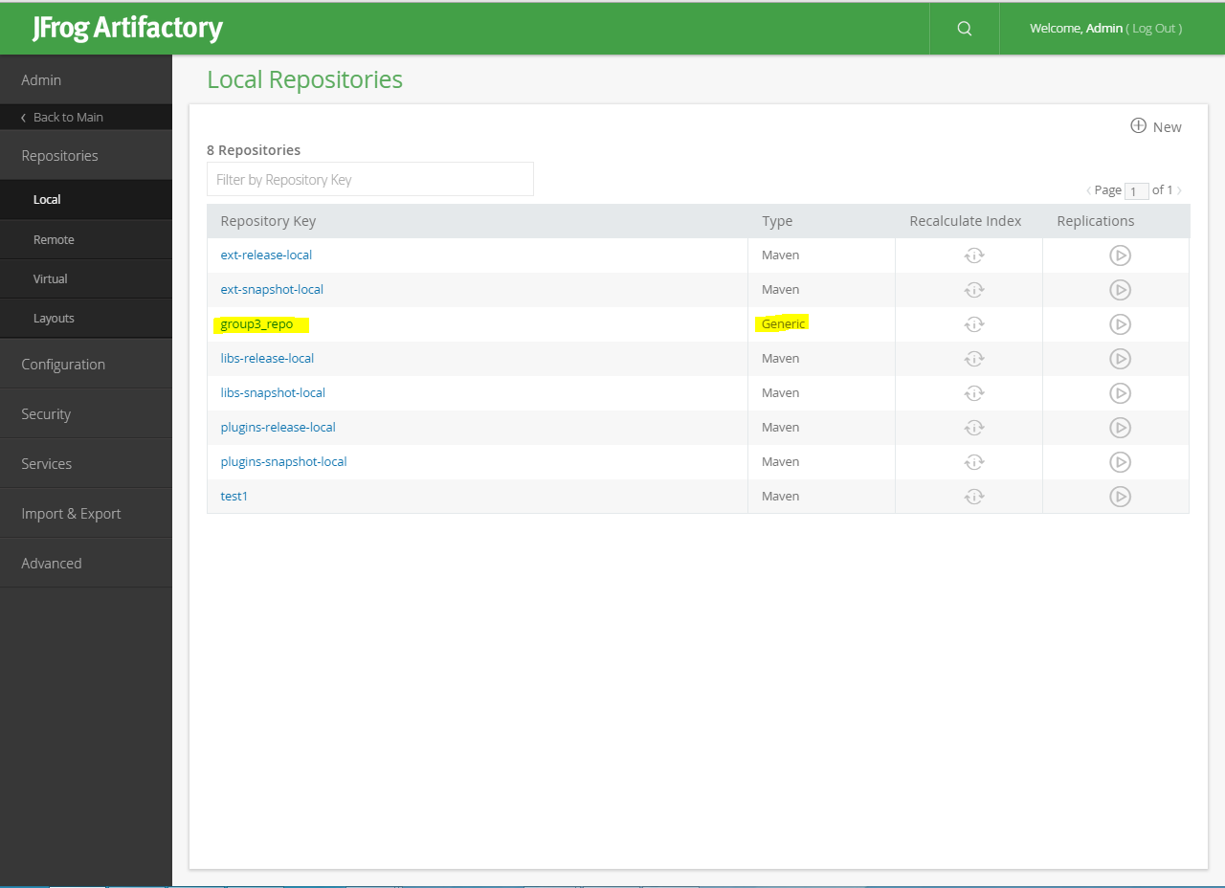

Step 2: Adding new user

* Go to **Admin** -> **Security** -> **Users** -> **New**
* Add **username**, **Email address** and **password** and save it

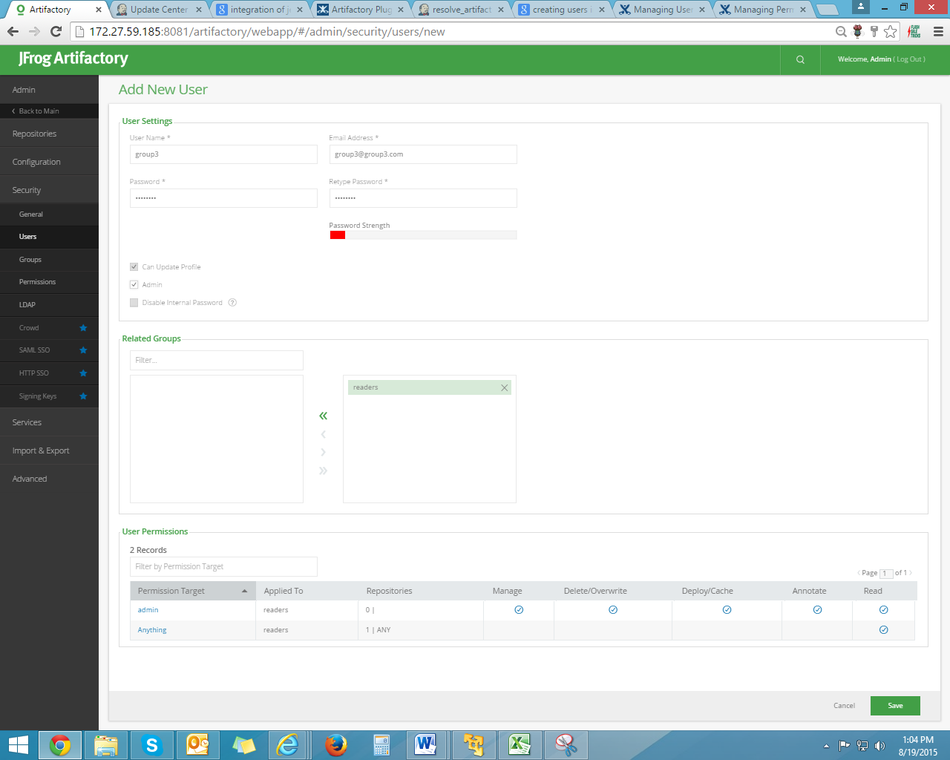

Step 3: Setting permissions

* Go to **Admin** -> **Security** -> **Permissions** -> **New**
* Add Permission name in **Name** and add repo from **available repositories** to **selected repositories** so that particular repo will have specific permissions assigned

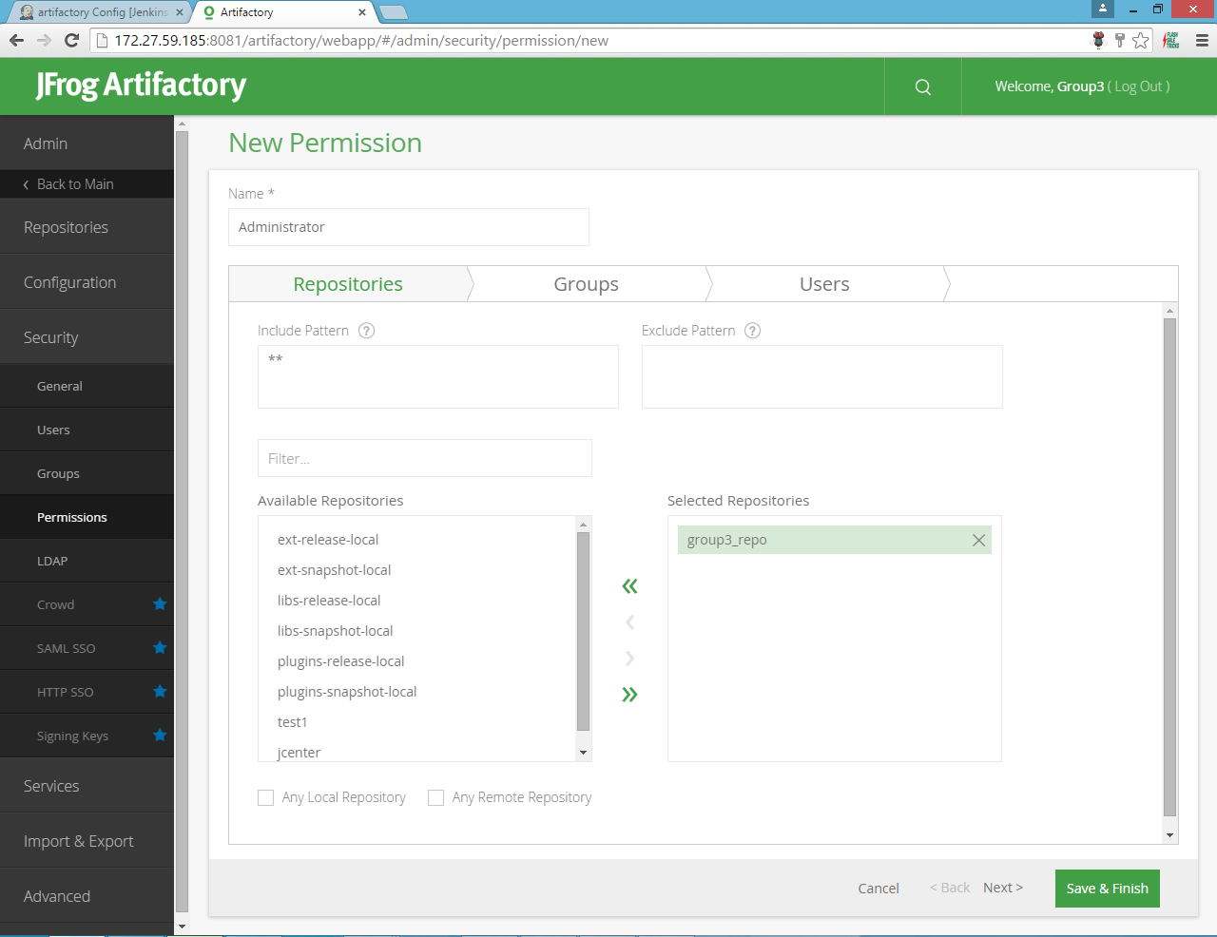

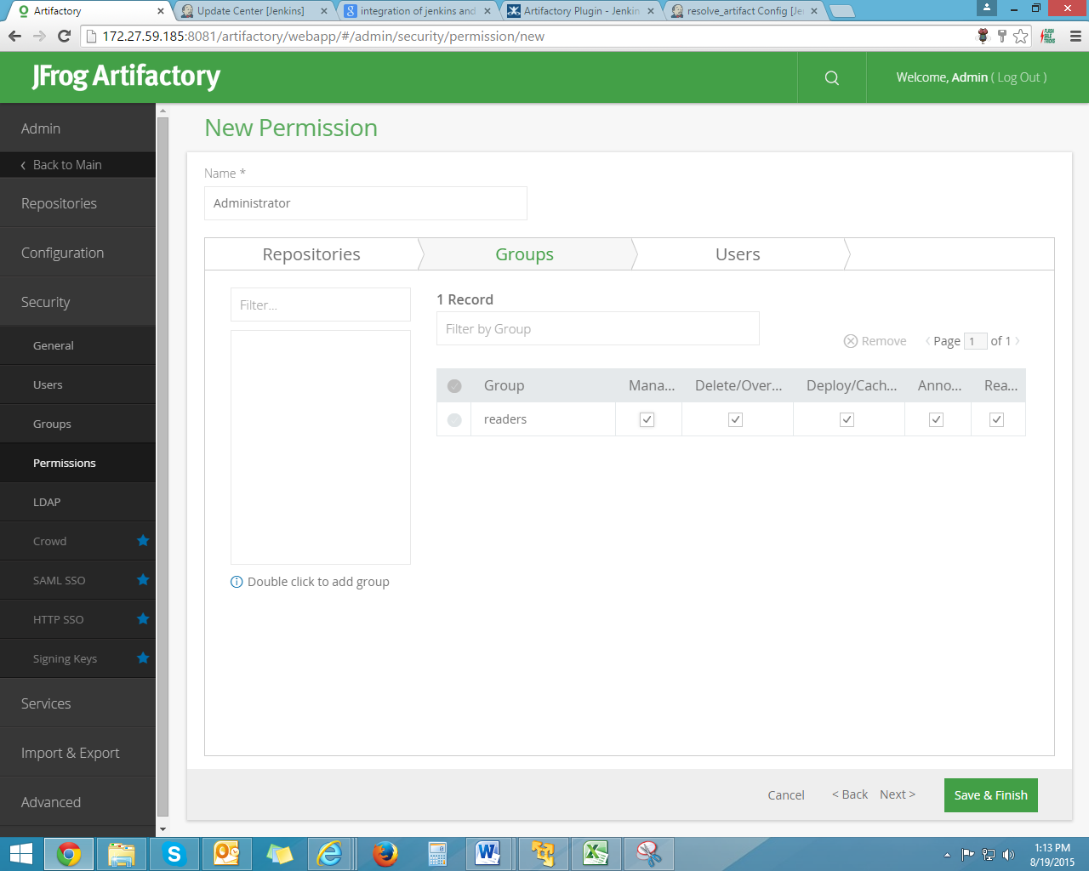

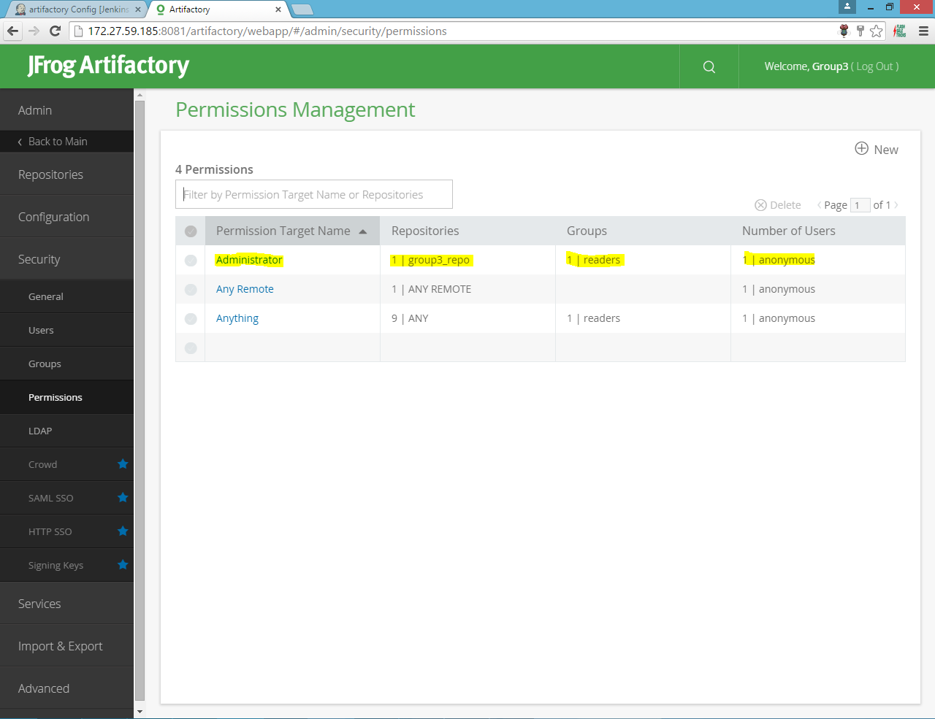

**INTEGRATION OF JENKINS AND ARTIFACTORY**

Step 1: Configuration in Jenkins

* Install **Artifactory plugin** in Jenkins
* Check **Generic Artifactory integration** checkbox
* Provide **Artifactory server url** and **target repositories**
* Check **Override default deployer credentials** checkbox and provide **username** and **password**
* Give Published Artifacts as **\*\*/*.war**
* Save and apply the changes
* Run the Jenkins build

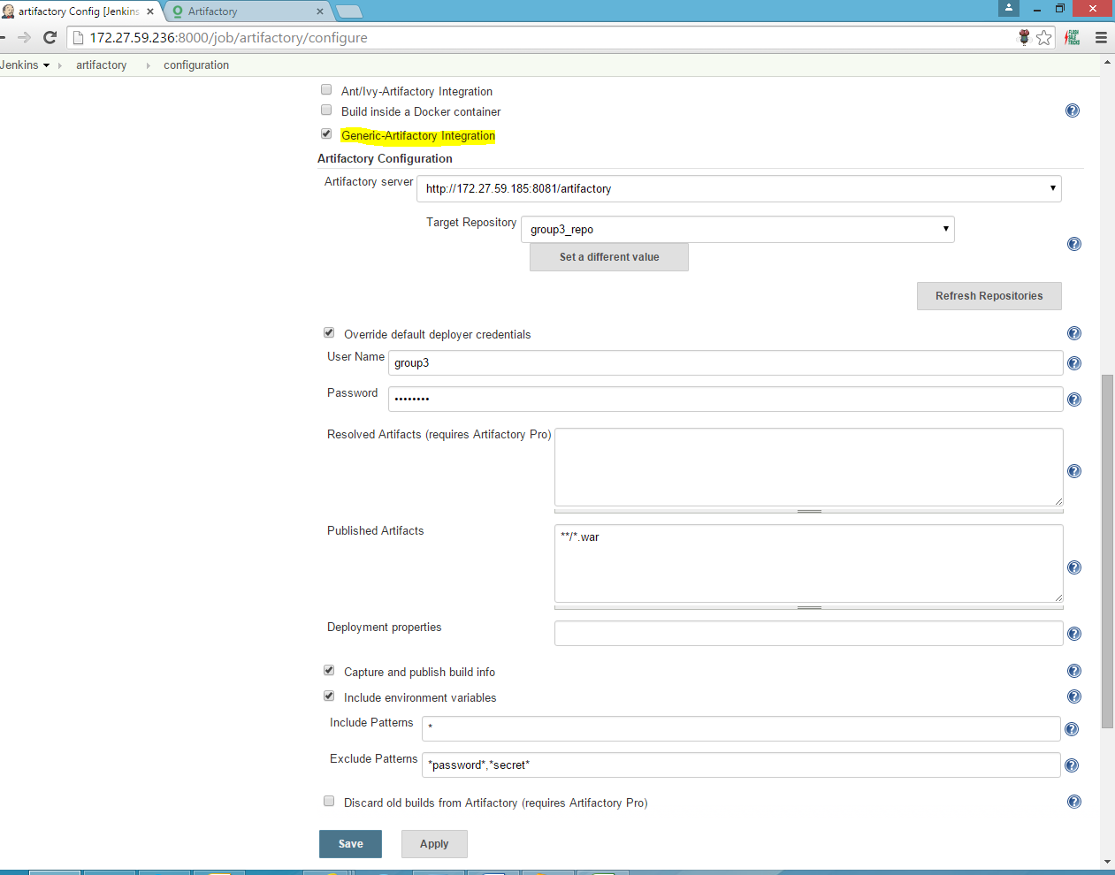

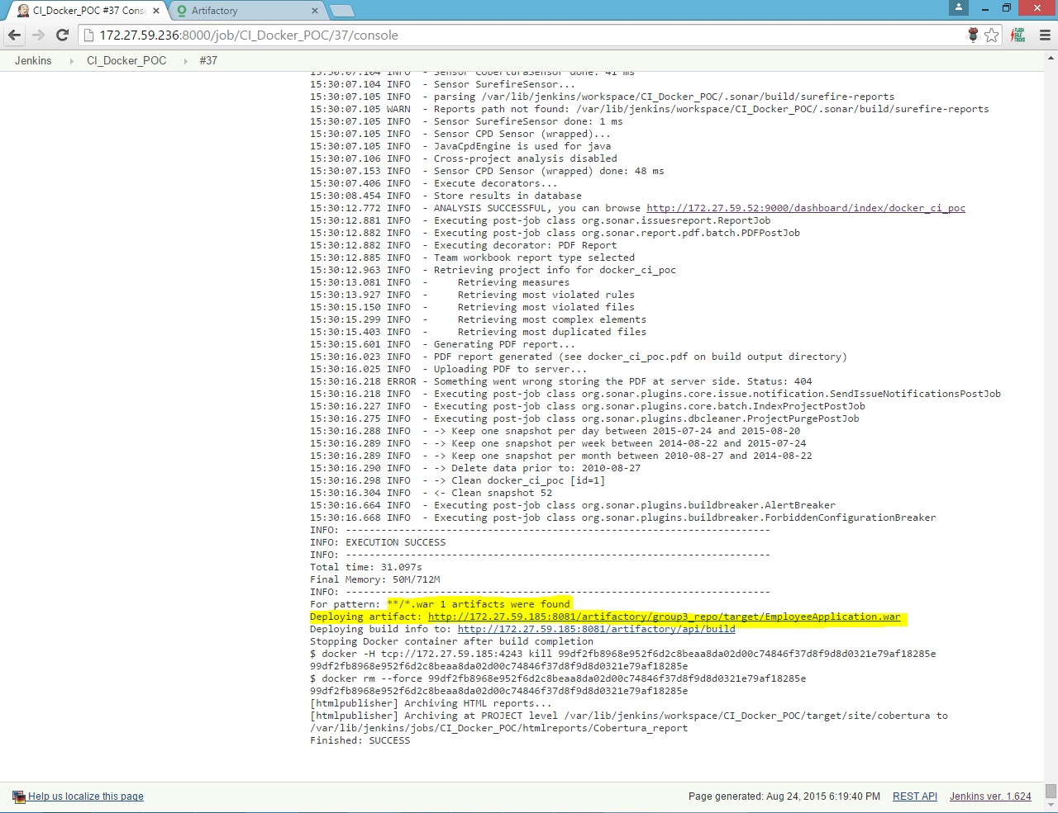

Step 2: Artifacts stored in Artifactory

* Go to **Artifacts** tab, artifacts are stored under target repo provided in jenkins
* **Artifact count** is also viewed as **1** in General tab

